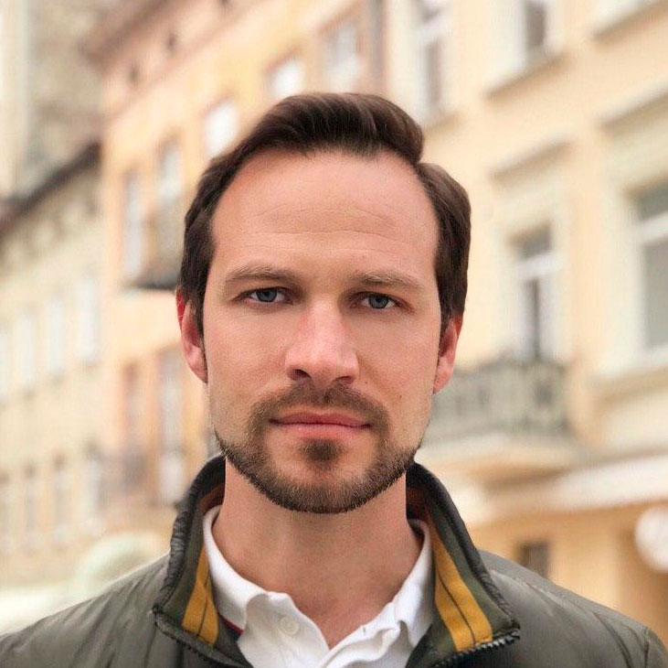
Contact information

Phone: +38 050 47 45 600  Email: andreydoroshuk@gmail.com  Skype: doroshuk-andrey |  |  | Andrii Doroshuk
 |  | Front-end Developer
Summary of Qualifications | 8 years worked as a guide in Europe, created new programs;  2 years - top manager, led the department of guides, was engaged in staff training;  Organized public speaking trainings;  Assiduous, scrupulous, constantly studying, sociable, responsible
Skills | HTML5, CSS3, LESS, SCSS, Angular, Bootstrap-4, GIT  VScode, Brackets, PhotoShop  JavaScript, Noode.js, JQ, MongoDB
Experience / IT related educational practice
Front-End Developer march – 2020
Freelance Currently made a website
http://t-shirtart.shop
http://test.t-shirtart.shop/
http://doroshuk.online/

System administrator 26 may - 01 september – 2010
Architectural company ТзОВ "Арніка"

Web Designer 20 october - 26 february – 2009
online store "Ф-Арт"

Languages | Ukrainian language native
Languages | Russian native speaker
Languages | English Intermediate
Education | [National University of Lviv Polytechnic]  [2009 - bachelor]
Education | [National University of Lviv Polytechnic]  [2010 - specialist]

Additional education (courses, trainings) | JAVA SCRIPT FUNDAMENTAL - SoftServe IT Academy [Series HL № 2497/2020]  WEB UI CERTIFICATION - SoftServe IT Academy [Series ZD № 2494/2020]  Self Management - Radislav Gandapas  Sales Tactics - Michael Tracy  Body Language - Allan Pease  Oratory - Andrii Stepura  Speed reading – Hordiy Ostapovich
Hobbies | Soap making, travel, history, tennis, swimming, IT

